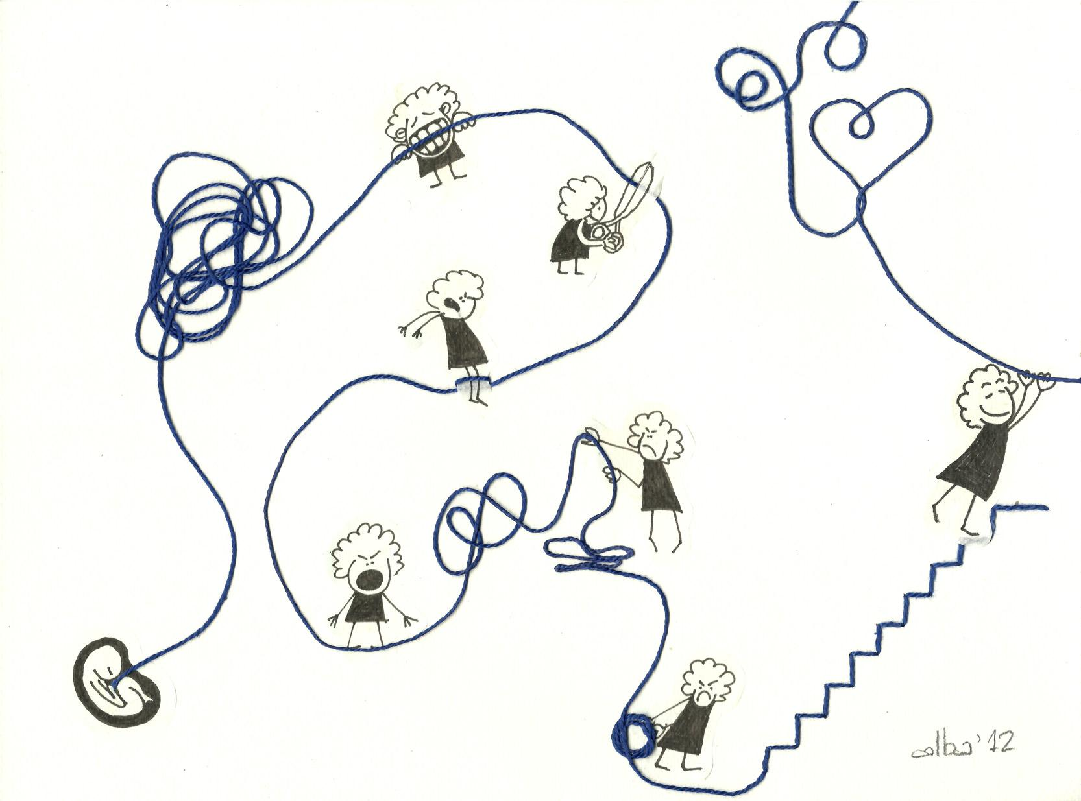

The Way It Is

There’s a thread you follow. It goes among
things that change. But it doesn’t change.
People wonder about what you are pursuing.
You have to explain about the thread.
But it is hard for others to see.
While you hold it you can’t get lost.
Tragedies happen; people get hurt
or die; and you suffer and get old.
Nothing you do can stop time’s unfolding.
You don’t ever let go of the thread.

By William Stafford, from The Way It Is, 1998

